2023-2024 QUICK REFERENCE GUIDE
Applications Opening Date: October 1, 2022
- Apply for the Free Application for Federal Student Aid (FAFSA):
  - Application website: https://studentaid.gov/h/apply-for-aid/fafsa
- Apply for the Florida Financial Aid Application (FFAA)
  - Application website: https://www.floridastudentfinancialaidsg.org/SAPHome/SAPHome?url=home
- Apply for Private Scholarships:
  - High Schools, Districts, Private Organizations, Post-secondary Institutions.
Reference Materials:
- Determining Student’s dependency status for FAFSA:
  - Website: Dependency Status | Federal Student Aid
- Determining Who is a Parents for FAFSA:
  - Attachment Page 3-4, website: https://studentaid.gov/sites/default/files/who-is-my-parent.png
Financial Aid Awards-Nonfictions/Disbursements:
- Each Individual Post-Secondary Institution will have their own distinctive:
  - Priority Date for a completed FAFSA/Financial Aid Applications
  - Financial Aid award notification process
  - Financial Aid distribution process
Special Notations:
- Determining Students Florida Residency requirements:
  - Florida resident status are determined by the student's postsecondary institution.
- Ultimate responsibility belongs with the student for every required application, request for additional documentation and meeting applicable deadlines.

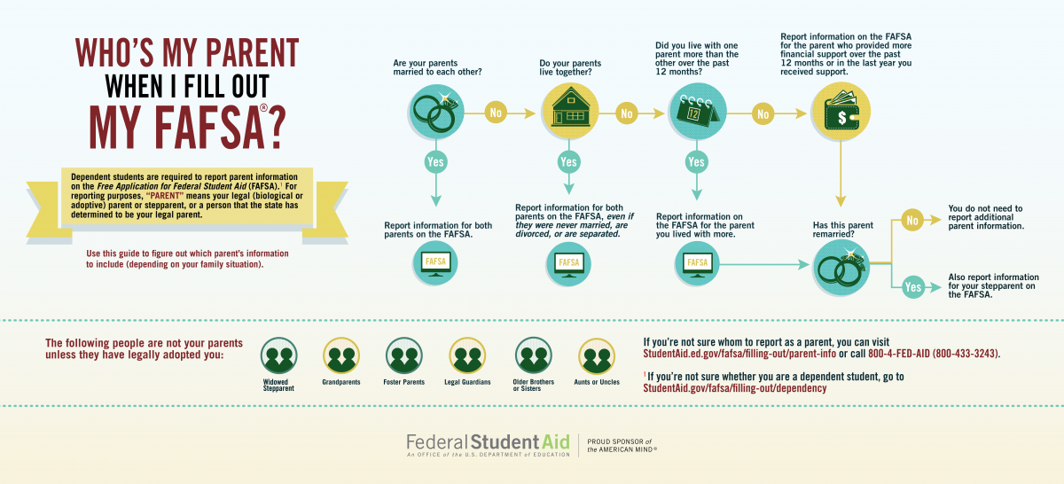

Who is my parent according to the FAFSA® form?
If you need to report parent information, here are some guidelines to help you:
- If your legal parents (your biological and/or adoptive parents, or parents as determined by the state [e.g., a parent listed on your birth certificate]) are married to each other, answer the questions about both of them, regardless of whether your parents are of the same or opposite sex.
- If your legal parents are not married to each other and live together, answer the questions about both of them, regardless of whether your parents are of the same or opposite sex.
- If your legal parent is widowed or was never married, answer the questions about that parent.

What if my parents are divorced or separated?
In this case, how you fill out the FAFSA form depends on whether your parents live together or not.
Keep the following in mind as you read this section:
- For FAFSA purposes, your married parents are separated if they are considered legally separated by a state, or if they are legally married but have chosen to live separate lives, including living in separate households, as though they were not married.
- When two married persons live as a married couple but are separated by physical distance (or have separate households), they are considered married for FAFSA purposes.

Divorced or Separated Parents Who Do Not Live Together
If your parents are divorced or separated and don’t live together, answer the questions about the parent with whom you lived more during the past 12 months.
If you lived the same amount of time with each divorced or separated parent, give answers about the parent who provided more financial support during the past 12 months or during the most recent 12 months that you actually received support from a parent.

Divorced or Separated Parents Who Live Together
If your divorced parents live together, you’ll indicate their marital status as “Unmarried and both legal parents living together," and you will answer questions about both of them on the FAFSA form.
If your separated parents live together, you’ll indicate their marital status as “Married or remarried" (NOT “Divorced or separated"), and you will answer questions about both of them on the FAFSA form.

What if I have a stepparent?
If you have a stepparent who is married to the legal parent whose information you’re reporting, you must provide information about that stepparent as well.
EXCEPTION: The FAFSA form asks about your parents’ education level. For these two questions, your parents are considered to be your birth parents or adoptive parents—your stepparent is not your parent in these questions.
Including your stepparent’s information on the FAFSA form helps create an accurate picture of your family’s total financial strength.

What if my stepparent is widowed?
If your stepparent was married to your parent but is now widowed, that stepparent doesn’t count as a parent on your FAFSA form unless he or she has legally adopted you.

What if my parents are in a same-sex marriage?
Same-sex couples must report their marital status as married if they were legally married in a state or other jurisdiction (foreign country), without regard to where they live or where the student will be going to school.

