Tocoi Creek School Counseling Newsletter

January 2022

Information Technology Solutions

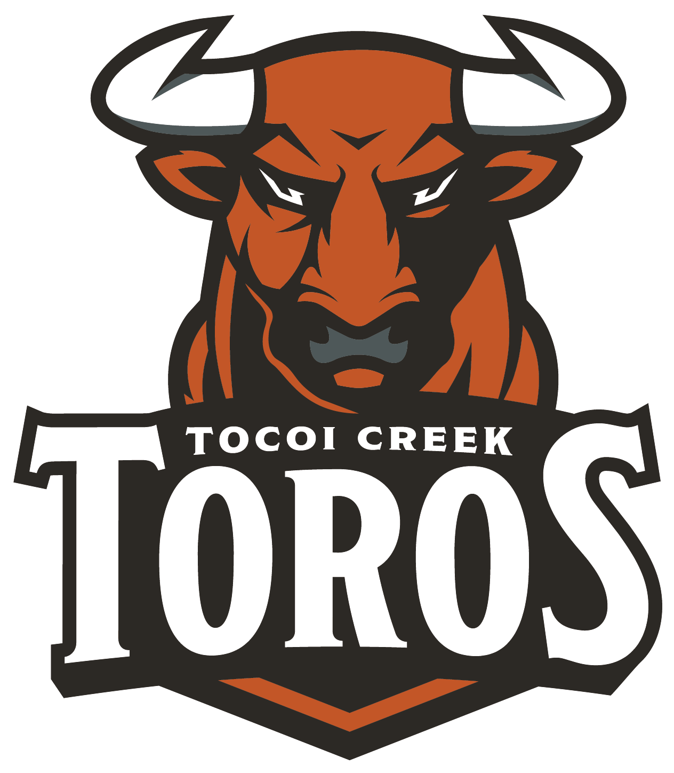

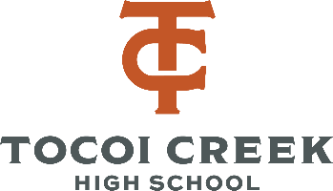an

School Counseling Team:

Rachel Blount: Last Names A-G Rachel.Overholt@stjohns.k12.fl.us

D’Erica Gibbs:Last Names H-N & Collegiate High School D’Erica.Gibbs@stjohns.k12.fl.us

Linda M. Smith: Last Names O-Z

Linda.M.Smith@stjohns.k12.fl.us

Chassity Johnson: Registrar Chassity.Johnson@stjohns.k12.fl.us

Marvin Jenkins: Computer Operator

Marvin.Jenkins@stjohns.k12.fl.us

Kimberly Doyle: Secretary

Kimberly.Doyle@stjohns.k12.fl.us

Upcoming Dates:

**Jan 6:** Return to school

**Jan. 6:** Academy applications open

**Jan. 10-21:** Pick electives on HAC

**Jan. 17:** No School: MLK day

**Jan. 19:** Report cards on HAC

**Jan. 19:** Navy Presentation

**Jan. 25:** FGCU Visit

**Jan. 26:** UNF Visit

**Jan. 27:** South Alabama Visit

**Jan. 31:** Start individual registration appointments

Appointment Links:

Rachel Blount: https://calendly.com/rachel-blount

D’Erica Gibbs: https://calendly.com/derica-gibbs-1

Linda Smith: https://calendly.com/lindamsmith

**College and military visits are being scheduled!**

The visits are located on the window of the Counselor suite, and on the Schoology School Counselor calendar.

College visits will be either at 8:45am – 9:15am or during Toro time – in the HUB.

All military presentations will be during Toro time.

If a student is interested in attending a college or military presentation, please stop by the Counselors office to receive a pass or get tagged for a Toro time session.

*Upcoming College visits* –

January 25: FGCU (8:45am)

January 26: UNF (8:45am)

January 27: South Alabama (8:45)

February 2: St. Johns River State College (Toro Time)

*Upcoming Military presentation* –

Navy – January 19th (Toro time presentation); table available during lunches for additional questions as well

Army - table available during lunches every 2nd and 4th Thursday every month (beginning January 27th)

Free Test Prep Resources:

The Florida Partnership will offer their third **Virtual Student/Parent Night on January 25, 2022, at 6 pm EST,**  and the topic of this webinar will be ***Understanding PSAT Student Score Reports****.***Register in advance for this webinar**:

[https://collegeboard.zoom.us/webinar/register/WN__MQGH_ksSMudrWv_CfxfCg](https://nam12.safelinks.protection.outlook.com/?url=https%3A%2F%2Fcollegeboard.zoom.us%2Fwebinar%2Fregister%2FWN__MQGH_ksSMudrWv_CfxfCg&data=04%7C01%7CLinda.M.Smith%40stjohns.k12.fl.us%7C71d265bbb3a744926d9f08d9d517a997%7Cb3b3d057fc124f3f92f472be6e844351%7C0%7C0%7C637775119896443342%7CUnknown%7CTWFpbGZsb3d8eyJWIjoiMC4wLjAwMDAiLCJQIjoiV2luMzIiLCJBTiI6Ik1haWwiLCJXVCI6Mn0%3D%7C3000&sdata=WUBJPdqR6AAoqrSki8kG4Mjwfrls7od8Qxo86FuxIL0%3D&reserved=0)

ACT Websites: [ACT Test Prep](https://www.act.org/content/act/en/products-and-services/the-act/test-preparation.html)

[Printable ACT Full Legnth Practice Tests](https://blog.prepscholar.com/printable-act-practice-tests-5-free)

ACT Phone App: [ACT Prep App](https://play.google.com/store/apps/details?id=com.varsitytutors.learningtools.act&hl=en)

SAT: [College Board Test Prep](https://collegereadiness.collegeboard.org/sat/practice) (Khan Academy!)

Both: [SAT/ACT Practice Tests](https://www.powerscore.com/sat/help/content_practice_tests.cfm)

[March 2 Success Courses](https://www.march2success.com/main/courses)

**You can review graduation requirements here:** <https://www-tchs.stjohns.k12.fl.us/guidance/graduation-requirements/>

**Phase 2 of registration will begin on January 31st and run until spring break.**

In Phase 2, students will have the opportunity to meet **individually** with their counselor. We will discuss the academics that were recommended by the teachers, the electives that were selected by the student, and the overall big picture of graduation requirements, college plans, etc. We will answer questions and make any necessary adjustments that this time.

It is time to start preparing for the 22-23 school year! Registration will occur in phases.

**Phase 1 is happening NOW!** Students received information via email and English class on January 10th about registering for their **elective** classes through HAC. Students and parents should not stress about academics in this phase. We simply want you to select classes that you would enjoy taking. Students will have the opportunity to discuss their choices and make changes when they meet with their counselor in phase 2. You can view the course catalog to get more information here: <https://www-tchs.stjohns.k12.fl.us/registration/courses/>

**Students have until January 21st to select their electives in HAC!**

Tocoi Creek

School Counseloing

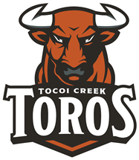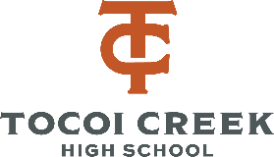

Bright Futures and Registration

Bright Futures GPA is calculated differently then their TCHS GPA.

Bright Futures **only** considers the student’s 16 core academic credits. Bright Futures uses the BEST courses in each subject area, so student’s can improve their GPA by taking additional courses beyond those required for graduation.

Core Courses Include:

* 4 best English
* 4 best Math
* 3 best Science
* 3 best Social Studies
* 2 best World Language*

**Note that a World Language is NOT required for graduation, but Bright Futures and the state universities require students take 2 years of the SAME world language for eligibility.**

**Common Registration Questions:**

Can I meet with my counselor now? Students are always welcome to meet with their counselor, but please wait until phase 2 for registration appointments to allow us time to prepare and meet other student needs.

Can parents join the appointment in phase 2?

Space limits our ability to include parents during the individual appointments. If parents have questions, they should relay them through their student or reach out to the counselor separately through email.

My student wants to participate in **Dual Enrollment**. What do they need to do?

Make sure that they meet eligibility requirements here: <https://www-tchs.stjohns.k12.fl.us/guidance/dual-enrollment/>. **Students must have the qualifying test scores by April 1st**. Students should also indicate thier plans in their registration appointment and make sure to join the Dual Enrollment Schoology group using access code: RCGS-QGPH-RZCG6.

My student is applying for an academy. Do I still need to pick electives? Yes, once students are selected for academies, we will make the appropriate adjustments.

Do students have to take a World Language? No, a language is NOT required for graduation. It IS required for Bright Futures and university admissions.

Can students take a class on-line? Yes, just let your counselor know during your appointment.

Can my student leave early and get credit for working? Yes, 11th & 12th graders can get elective credit for working. Students should discuss this during their appointment.

How do I see the course progressions? Check them out here: <https://www-tchs.stjohns.k12.fl.us/registration/courses/>

*Our TCHS School Counseling Page is up and running! Come check it out for a TON of resources including SAT/ACT test prep and more!*

Advanced Placement or Dual Enrollment?

Choosing between Advanced Placement and Dual Enrollment is a personal decision. Here are some things to help you consider your options.

**Are you a good test taker?**

AP requires that students pass the AP exam at the end of the year to get the college credit. DE credit is based on the student’s grade in the course.

**Where do you plan to attend college?**

AP and DE are both accepted inside the state of Florida. Outside of Florida, AP is more nationally recognized and DE credits are not guarenteed.

**How committed are you?**

AP courses are not included in student’s college GPA. DE courses are and low grades can result in losing financial aid and/or scholarship opportunities.

Tocoi Creek

School Counseloing

FRESHMAN:

Know graduation requirements.

Understand GPA

Keys to Success (tutoring, study skills, etc)

Community Service

Goal Setting

SOPHOMORES:

Review graduation requirements

PSAT

Extracurricular suggestions

Dual enrollment

Explore college & career options

JUNIORS

Review graduation requirements

Create post secondary plan including: SAT/ACT/ASVAB, NCAA registration, Financial Aid, College search, & next steps document.

**School Counseling Curriculum**