Tocoi Creek School Counseling Newsletter

December 2021

Information Technology Solutions

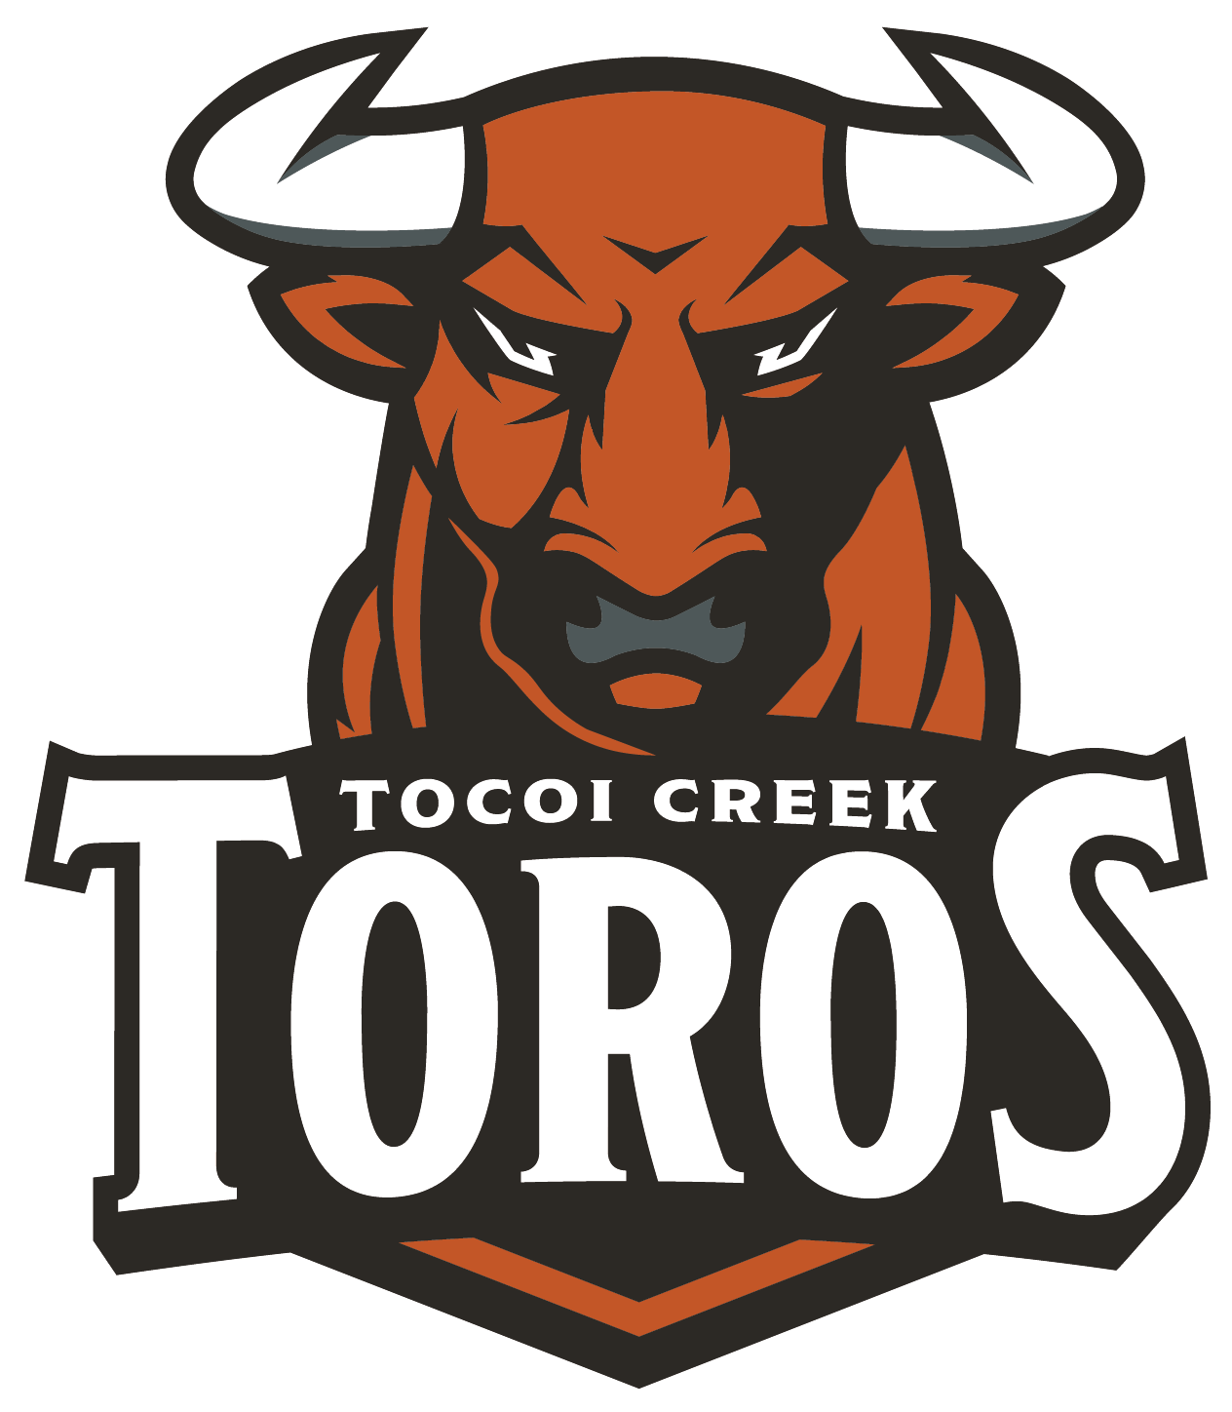

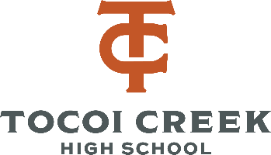

**Junior Meetings/ College Visits**

The counselors have been meeting individually with each Junior. During the meetings, we reviewed first quarter grades, graduation requirements/status, post-secondary planning, and next steps.

During the visit, students were given resources for career interest inventories and college search engines. As your family is traveling this holiday season, we hope that you consider utilizing some of that time to visit potential colleges and universities in preparation for the upcoming application season.

School Counselors are also in the process of organizing college reporesentatives coming to viist us here at TCHS. **You can see who has already been scheduled to come on the calendar in the School Counseling schoology group.** Look out for information to sign up and additional schools in the near future.

**Exam Strategies for Success:**

1. Make the most of class time beforehand
2. Keep study materials organized
3. Create flashcards & visuals
4. When your brain is getting tired, switch which class you are studying for to keep it fresh.
5. Utilize tutoring resources
6. Test your knowledge and quiz yourself
7. Reward yourself and take breaks
8. Get a good night’s sleep
9. Eat healthy and eat breakfast

Students needing to take (or retake) the Algebra 1 EOC will be testing Dec. 6-10. They should have received their specific test date on 12/3/21.

Semester exams will be given from Dec. 16-21st. Students who miss their exam will have to take their make-up exams after the break.

Dual Enrollment Follow Up

Thank you to all the students who came to the Dual Enrollment general information presentations this past month. Students received lot of information about our academic dual enrollment partnership with St. Johns River State College.

For students who were unable to participate, please join our Tocoi Creek Dual Enrollment Schoology page. Access Code: RCGS-QGPH-RZCG6. On this page, there are regular updates, presentations, and more.

Please remember – those who plan to participate must meet the testing deadline of **APRIL 1, 2022**!!!  All testing (PERT, SAT or ACT) results must be submitted to Mrs. Gibbs, dual enrollment contact, by **April 1, 2022**.

**EXAM SEASON IS HERE!**

It is time for teachers to start making course recommendations for the 22-23 school year. Teachers will be reviewing student’s test scores, current grades, and their effort in class to make their recommendations. Student’s, parents, and teachers are encouraged to discuss these as they are being determined. School counselors will be meeting with students’ individually with students during the 3rd quarter to finalize their selections for next year.

PSAT Scores will be available on-line through [College Board](https://collegereadiness.collegeboard.org/psat-nmsqt-psat-10/scores/getting-scores) on December 6th.

School Counseling Team:

Rachel Blount: Last Names A-G Rachel.Overholt@stjohns.k12.fl.us

D’Erica Gibbs:Last Names H-N & Collegiate High School D’Erica.Gibbs@stjohns.k12.fl.us

Linda M. Smith: Last Names O-Z

Linda.M.Smith@stjohns.k12.fl.us

Chassity Johnson: Registrar Chassity.Johnson@stjohns.k12.fl.us

Marvin Jenkins: Computer Operator

Marvin.Jenkins@stjohns.k12.fl.us

Kimberly Doyle: Secretary

Kimberly.Doyle@stjohns.k12.fl.us

Upcoming Dates:

**Dec. 6:** PSAT Score Return

**Dec. 6-10:** Alg. 1 EOC

**Dec. 16:** 1st and 2nd period exams

**Dec. 17:** 3rd and 4th period exams

**Dec. 20:** 5th and 6th period exams

**Dec. 21:** 7th period exam

**Dec. 21:** End of 2nd Quarter

**Dec. 22-Jan. 5:** Christmas Break

Appointment Links:

Rachel Blount: https://calendly.com/rachel-blount

D’Erica Gibbs: https://calendly.com/derica-gibbs-1

Linda Smith: https://calendly.com/lindamsmith

Tocoi Creek

School Counseloing

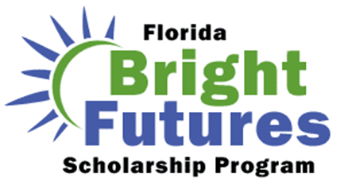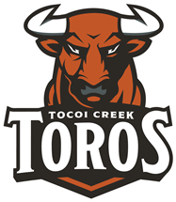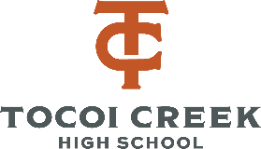

Students hoping to earn the Bright Futures scholarship need 75-100 hours of community service.

Students and parents can review the new requirements and paperwork here: <https://www-tchs.stjohns.k12.fl.us/guidance/home/community-service/>

Students can complete community service hours starting the summer between 8th and 9th grade through graduation day.

Students can view the number of community service hours on file in HAC.

Students looking for opportunities to volunteer can find them [here](https://www-tchs.stjohns.k12.fl.us/guidance/community-service/community-service-opportunities/).

Bright Futures- Community Service Updates!

Bright Futures GPA is calculated differently then their TCHS GPA.

Bright Futures **only** considers the student’s 16 core academic credits. Bright Futures uses the BEST courses in each subject area, so student’s can improve their GPA by taking additional courses beyond those required for graduation.

Core Courses Include:

* 4 best English
* 4 best Math
* 3 best Science
* 3 best Social Studies
* 2 best World Language*

**Note that a World Language is NOT required for graduation, but Bright Futures and the state universities require students take 2 years of the SAME world language for eligibility.**

Bright Futures- GPA/ Courses

What’s required for Bright Futures?

GPA, Test Scores, & Community Service!

21-22 ACT/SAT Test Dates

Free Test Prep Resources:

Deciding what test prep to use can often be overwhelming for students and parents. We encourage students to utilize FREE test prep for their initial study session. After they have taken their initial ACT & SAT, they can determine how much their score needs to improve. This can inform them of just how much they want to invest in paid test prep. Below we outlined some FREE test prep options that we have vetted and recommend.

ACT Websites: [ACT Test Prep](https://www.act.org/content/act/en/products-and-services/the-act/test-preparation.html)

[Printable ACT Full Legnth Practice Tests](https://blog.prepscholar.com/printable-act-practice-tests-5-free)

ACT Phone App: [ACT Prep App](https://play.google.com/store/apps/details?id=com.varsitytutors.learningtools.act&hl=en)

SAT: [College Board Test Prep](https://collegereadiness.collegeboard.org/sat/practice) (Khan Academy!)

Both: [SAT/ACT Practice Tests](https://www.powerscore.com/sat/help/content_practice_tests.cfm)

[March 2 Success Courses](https://www.march2success.com/main/courses)

*Our TCHS School Counseling Page is up and running! Come check it out for a TON of resources including SAT/ACT test prep and more!*

Tocoi Creek

School Counseloing

FRESHMAN:

Know graduation requirements.

Understand GPA

Keys to Success (tutoring, study skills, etc)

Community Service

Goal Setting

SOPHOMORES:

Review graduation requirements

PSAT

Extracurricular suggestions

Dual enrollment

Explore college & career options

JUNIORS

Review graduation requirements

Create post secondary plan including: SAT/ACT/ASVAB, NCAA registration, Financial Aid, College search, & next steps document.

**School Counseling Curriculum**